Table Screenshot to understand concept

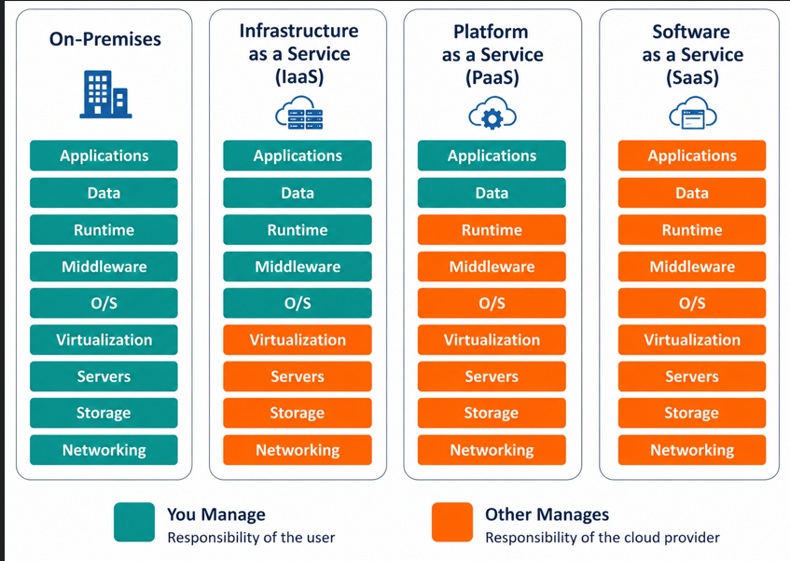

AWS VPC architecture with Public and Private Subnets using a NAT Gateway. SS below to understand concept

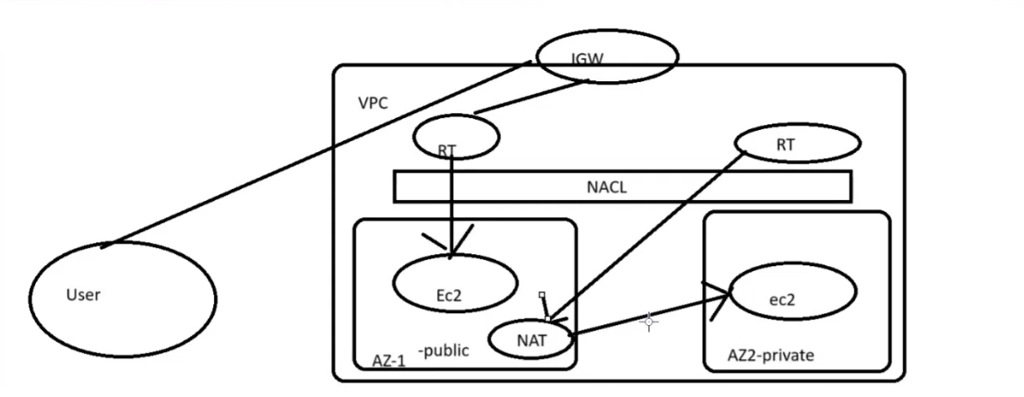
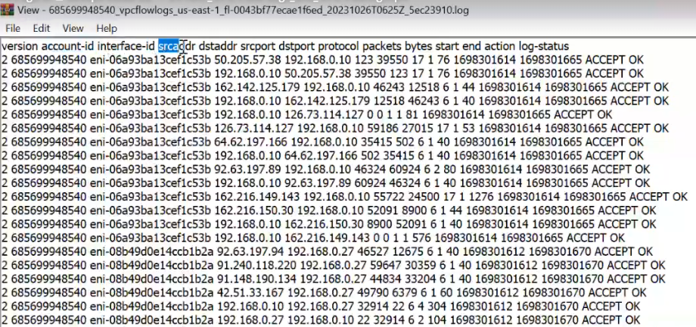

- IPA address class Range Table.
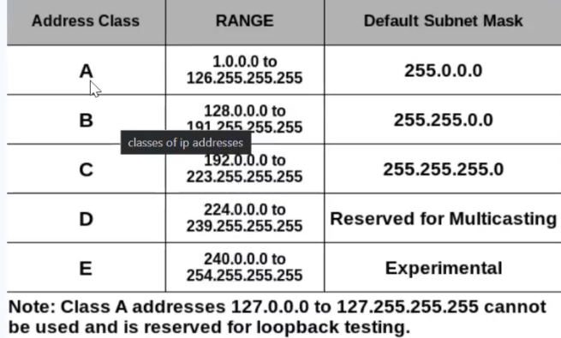

- AWS VPC Architecture with SG and NACLs
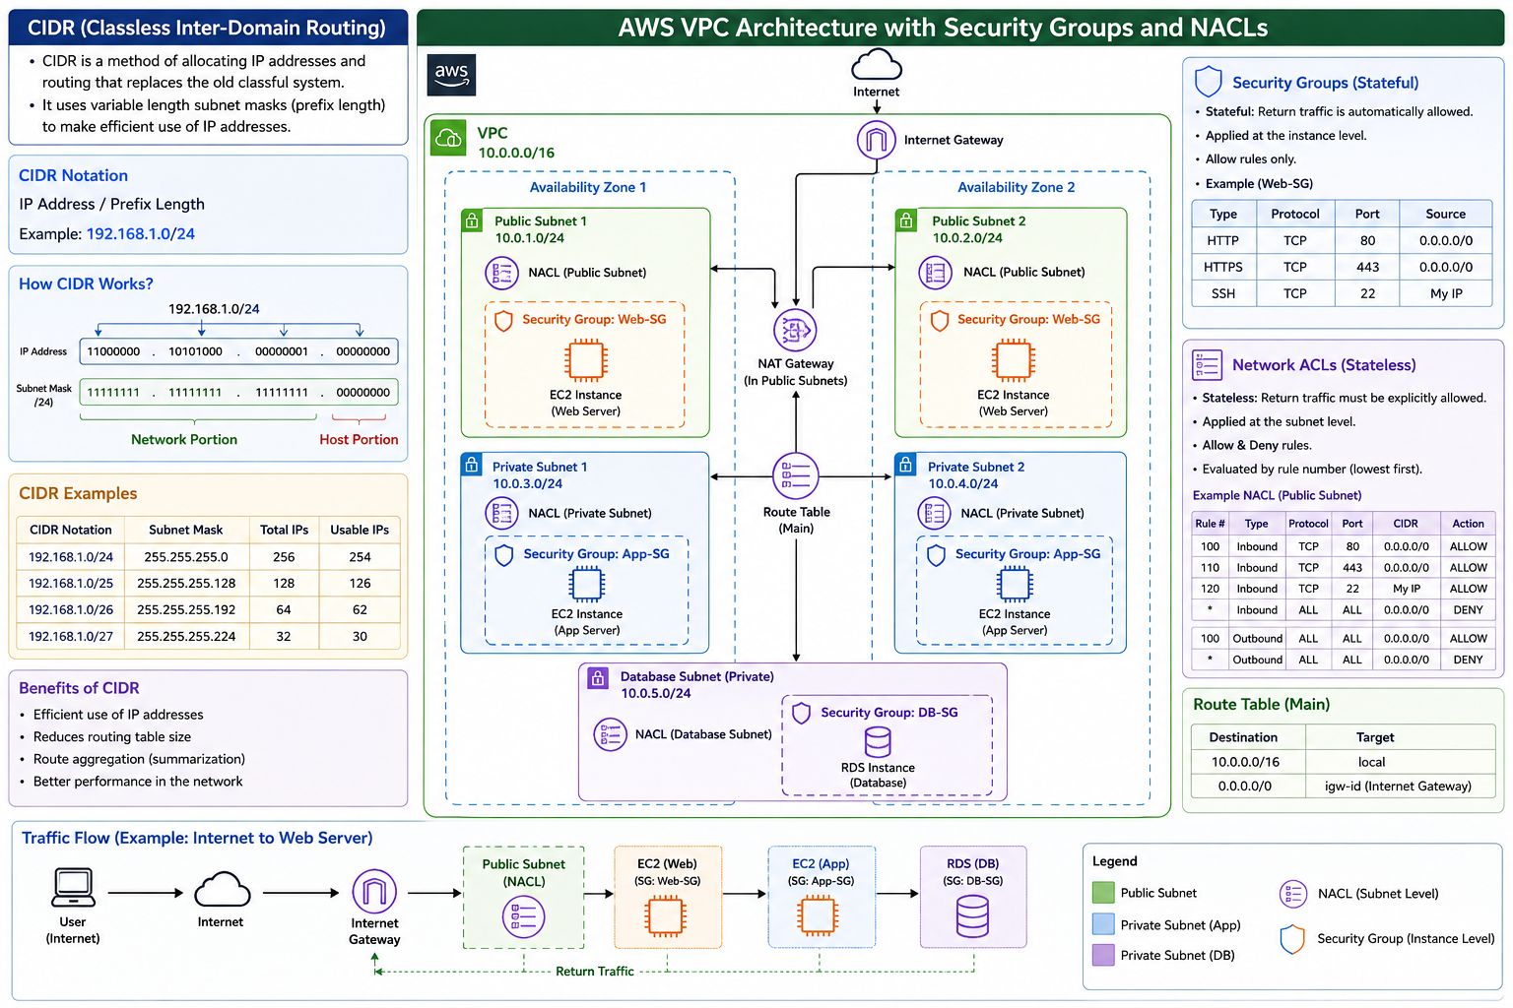

- Both VPC Peering and Transit Gateway are used to allow communication between VPCs, but they work differently.
- VPC Peering SS below:

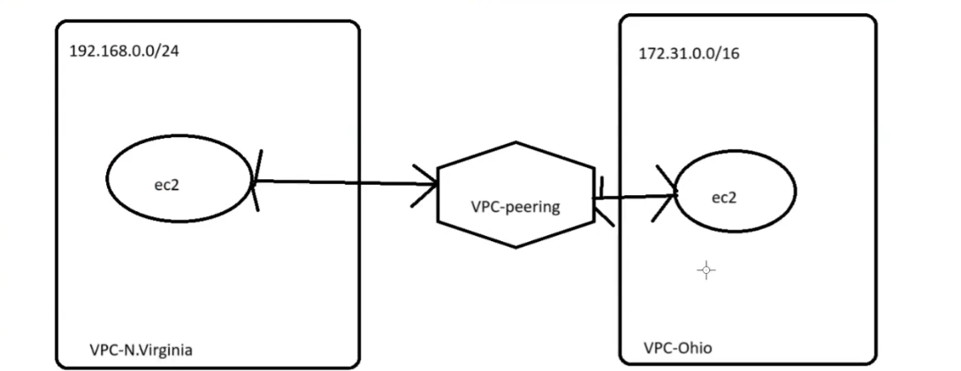
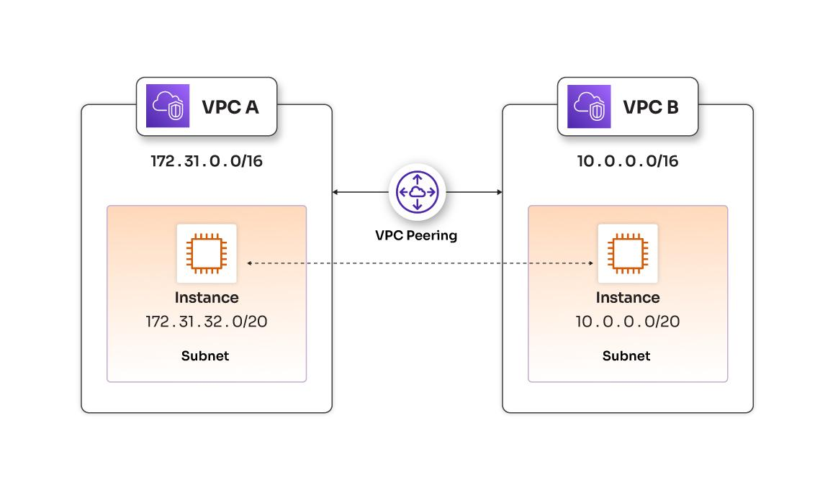

2. Transit Gateway
AWS Transit Gateway acts like a central networking hub.
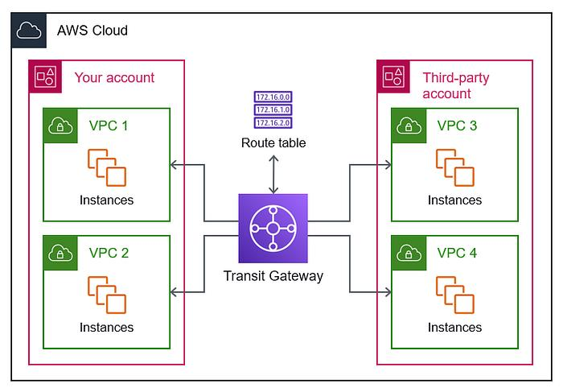
AWS Architecture
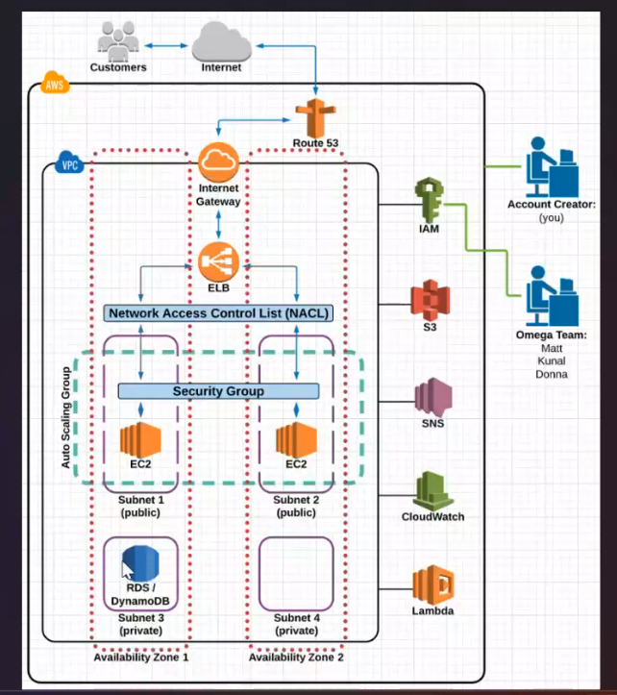
AWS Project Architecture flow
